AOI Monthly report

Pierre Baudin

February 10, 2017

Table of Contents

Product Quality Assurance 1

AOI defect rate KPI for Jan-2017 1

Annex 2

# Product Quality Assurance

## AOI defect rate KPI for Jan-2017

For the month of Jan-2017, the AOI defect rate is **59.99 PPM**.

Below is a summary of the data collected during Jan-2017:

## MONumber PartNumber PartName   
## 4000378: 1 603943 : 2 GEN III SMD Glue Side B : 1   
## 4000379: 1 604128 : 2 GEN III SMD Populated Side A : 1   
## 4000381: 1 602688 : 1 SMD Glue Side A (USB Primary PCB) : 1   
## 4000382: 1 604402 : 1 SMD Glue Side A (USB Secondary PCB) : 1   
## 4000390: 1 604407 : 1 SMD Glue Side B (GEN III) : 1   
## 4000395: 1 604455 : 1 SMD Reflow Side A (AT9012 3000K LED Board): 1   
## (Other):17 (Other):15 (Other) :17   
## Quantity Average   
## Min. : 100 Min. : 0.000   
## 1st Qu.: 1020 1st Qu.: 6.655   
## Median : 2100 Median : 44.330   
## Mean : 3918 Mean : 59.985   
## 3rd Qu.: 4250 3rd Qu.: 73.975   
## Max. :16020 Max. :348.505   
##

The following plot display the trend for each part number that have been processed in the SMT room and inspected using the AOI machine.

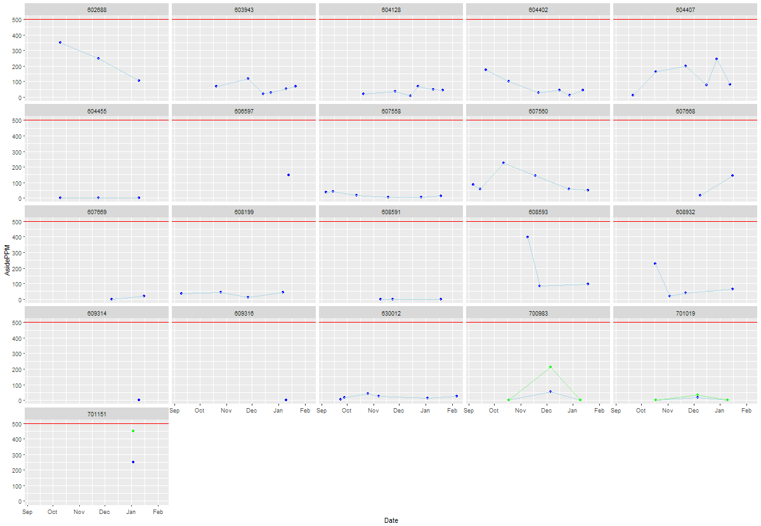

## Annex

To help with clarity, the following table list all the unique part numbers and part names with their respective MO quantity that have been produced during R MAOI:

## PartNumber  
## 1 630012  
## 2 701151  
## 3 608199  
## 4 604455  
## 5 602688  
## 6 609314  
## 7 609316  
## 8 604128  
## 9 603943  
## 10 700983  
## 11 701019  
## 12 604402  
## 13 604407  
## 14 606597  
## 15 608932  
## 16 607669  
## 17 607668  
## 18 607558  
## 19 607560  
## 20 608591  
## 21 608593  
## 22 604128  
## 23 603943  
## PartName  
## 1 SMD Reflow Side A (AT9012 3000K LED Board)  
## 2 SMD Reflow Side B (DCDALMRM2 V1P0)  
## 3 SMD Reflow Side A (EV-LEDFIRE-LITE)  
## 4 SMD Reflow Side B (LED Fire III Dish LED)  
## 5 SMD Reflow Side A (LED Fire III Dish LED)  
## 6 SMD Reflow Side B (Gen3 Semi Pro)  
## 7 SMD Reflow Side A (Gen3 Semi Pro)  
## 8 GEN III SMD Glue Side B  
## 9 GEN III SMD Populated Side A  
## 10 SMD Reflow Side A (DCDALCIP250-2 Bottom Board)  
## 11 SMD Reflow Side A (DCDALCIP250-2 Top Board)  
## 12 SMD Glue Side A (USB Primary PCB)  
## 13 SMD Glue Side A (USB Secondary PCB)  
## 14 SMD Reflow Side A (EV-PEARL-PRO-IP65-EM-WP LED Board)  
## 15 SMD Reflow Side A (AT9012TRI 3000K/6000K LED Board)  
## 16 SMD Reflow Side A (Ledfire Boost Full Feature (53-81-114-142)mA )  
## 17 SMD Reflow Side B (Ledfire Boost Full Feature (53-81-114-142)mA )  
## 18 SMD Reflow Side B (EV-LEDFIRE3-BAS)  
## 19 SMD Reflow Side A (EV-LEDFIRE3-BAS)  
## 20 SMD Reflow Side B (Ledfire III Dish LED PCB)  
## 21 SMD Reflow Side A (Ledfire III Dish LED PCB)  
## 22 SMD Glue Side B (GEN III)  
## 23 SMD Reflow Side A (GEN III)  
## Quantity  
## 1 16020  
## 2 315  
## 3 5001  
## 4 2100  
## 5 2100  
## 6 100  
## 7 100  
## 8 3000  
## 9 3000  
## 10 620  
## 11 620  
## 12 1430  
## 13 2814  
## 14 310  
## 15 1420  
## 16 4500  
## 17 4500  
## 18 15060  
## 19 15060  
## 20 4000  
## 21 4000  
## 22 2025  
## 23 2025